Confirmation Testing Report (1)
Bug Title: Logic Error in Average Calculation (Dividing by 4 instead of 5)
Status: PASSED ✅
1. Bug Description (Initial State)
The system was collecting 5 student grades through a loop, but the mathematical formula for the average was incorrect. It was dividing the total sum by 4 instead of 5, leading to inflated averages and incorrect letter grades.
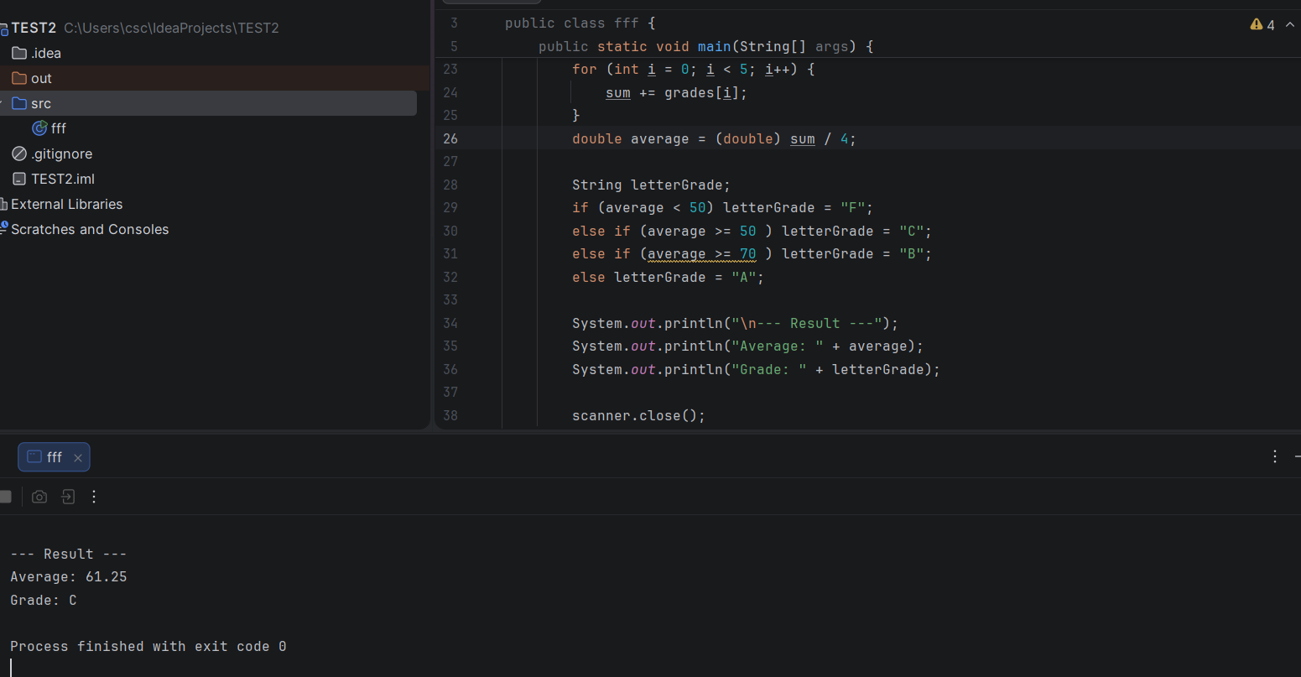
. Steps for Confirmation Testing
Open the source file StudentGrading.java.
Execute the program and input 5 sample grades (e.g., to reach a sum of 298).
Verify the calculated average against the expected mathematical result (298 \div 5 = 59.6).
Check if the correct Letter Grade is assigned based on the new average.
3. Test Results (After Fix)
Calculated Average: 59.6
Assigned Grade: C
Comparison: The output now matches the expected mathematical logic perfectly.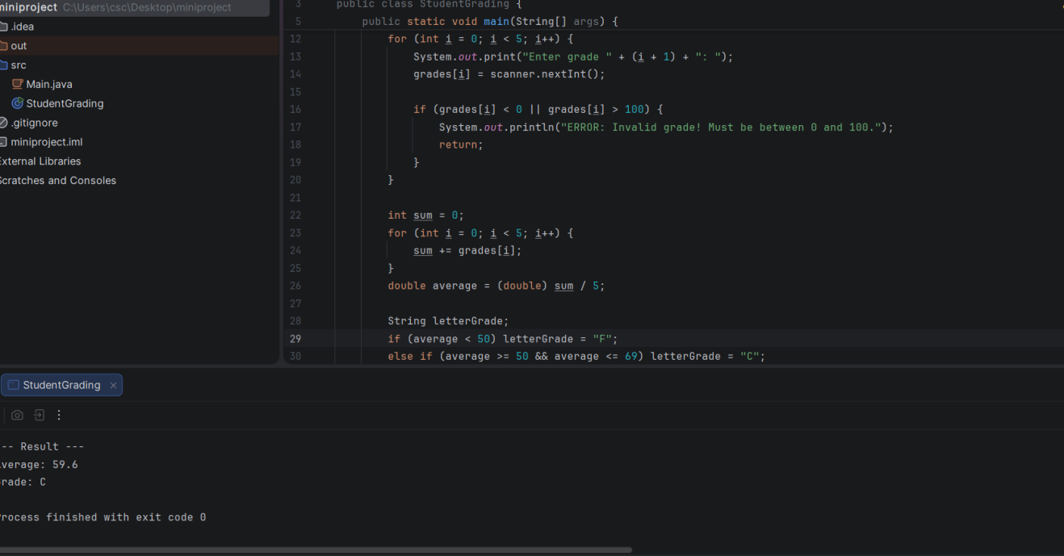
---------------------------------------------------------------------------------------------------------------
Confirmation Testing Report (2)
Bug Title: Incorrect Grade Logic (System always assigns "C" for any grade above 50)
Status: PASSED ✅
1. Bug Description (Initial State)
The system had a logic flaw in the if-else ladder. Because the condition else if (average >= 50) came before higher grades, any average above 50 (like 80 or 90) would trigger the "C" grade immediately and never reach the checks for "B" or "A".
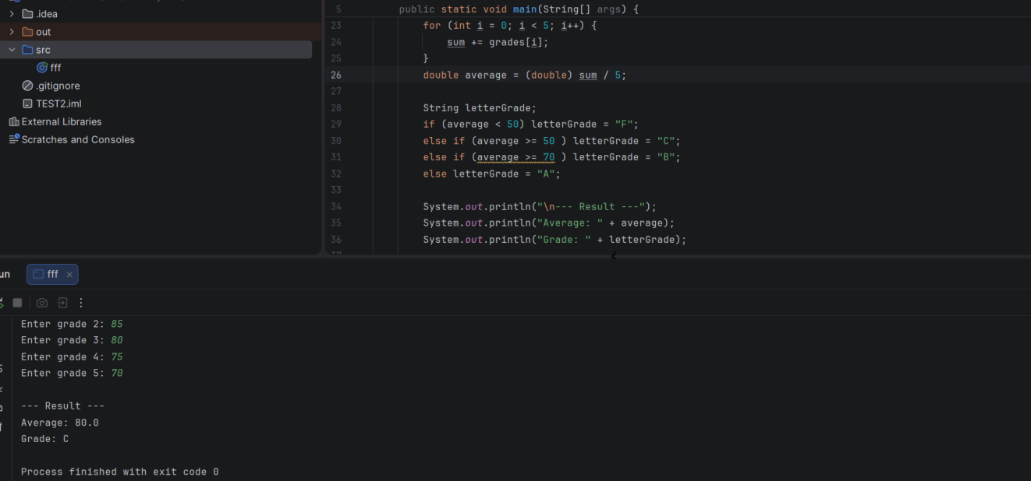
2. Steps for Confirmation Testing
Open the source file StudentGrading.java.
Run the program and enter high grades (Example: 90, 85, 80, 75, 70).
Verify that the final Letter Grade matches the high average (A or B) instead of defaulting to C.
3. Test Results (After Fix)
Validation: This prevents higher scores from being "trapped" in the "C" category.
Actual Output: entering high grades now correctly calculates the average and assigns the appropriate high grade (A or B) based on the score.
Evidence: The console now shows the correct grade mapping for scores above 70.
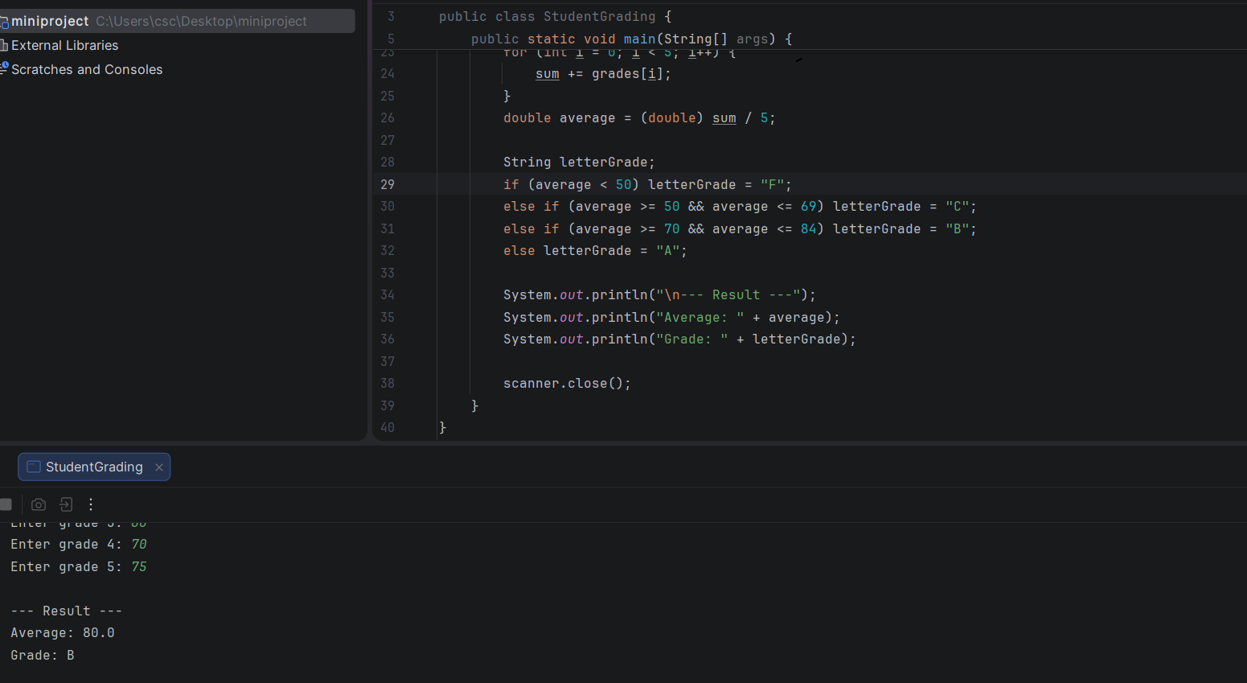
----------------------------------------------------------------------------------------------------
Confirmation Testing Report(3)
Bug Title: Missing Input Validation (System accepts marks > 100)
Status: PASSED ✅
1. Bug Description (Initial State)
The system lacked a validation check for user input. It was accepting marks outside the logical range (0-100), such as entering "120". This resulted in incorrect averages (e.g., 101.0) and logically impossible grades.
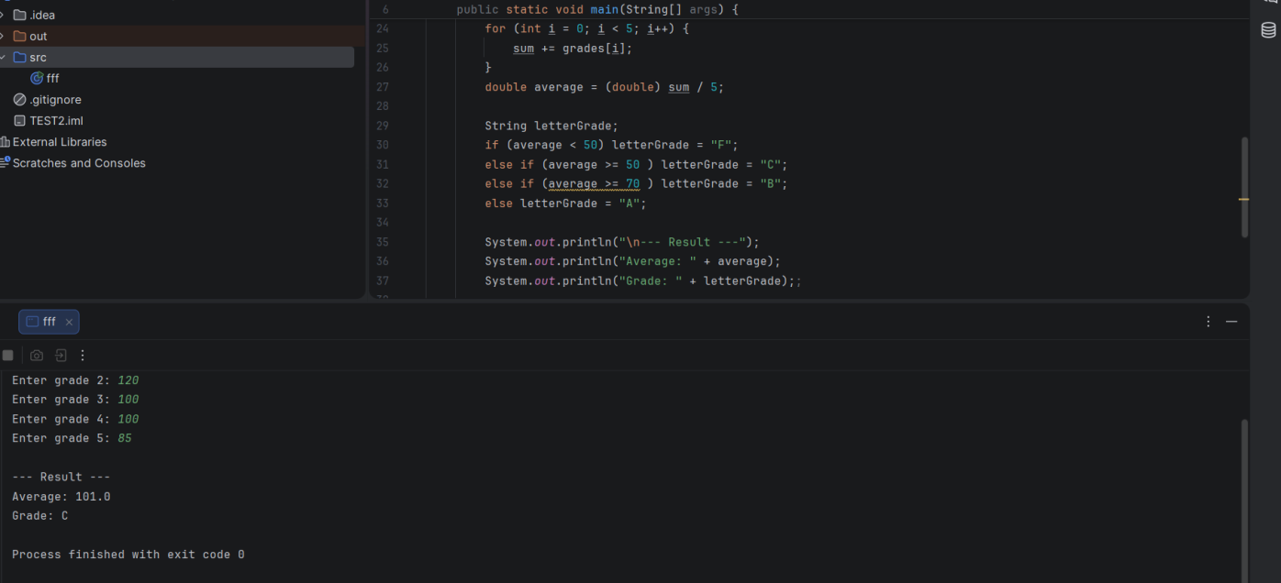

2. Steps for Confirmation Testing
Open the source file StudentGrading.java.
Run the program.
Try to enter an invalid mark (Example: 120 or -5).
Verify that the system displays an error message: "ERROR: Invalid grade! Must be between 0 and 100." and stops execution (or asks for re-entry).
3. Test Results (After Fix)
Actual Output: When entering "120", the system successfully catches the error and prints the "Invalid grade" message.
Evidence: The second screenshot shows the code with the fix implemented.
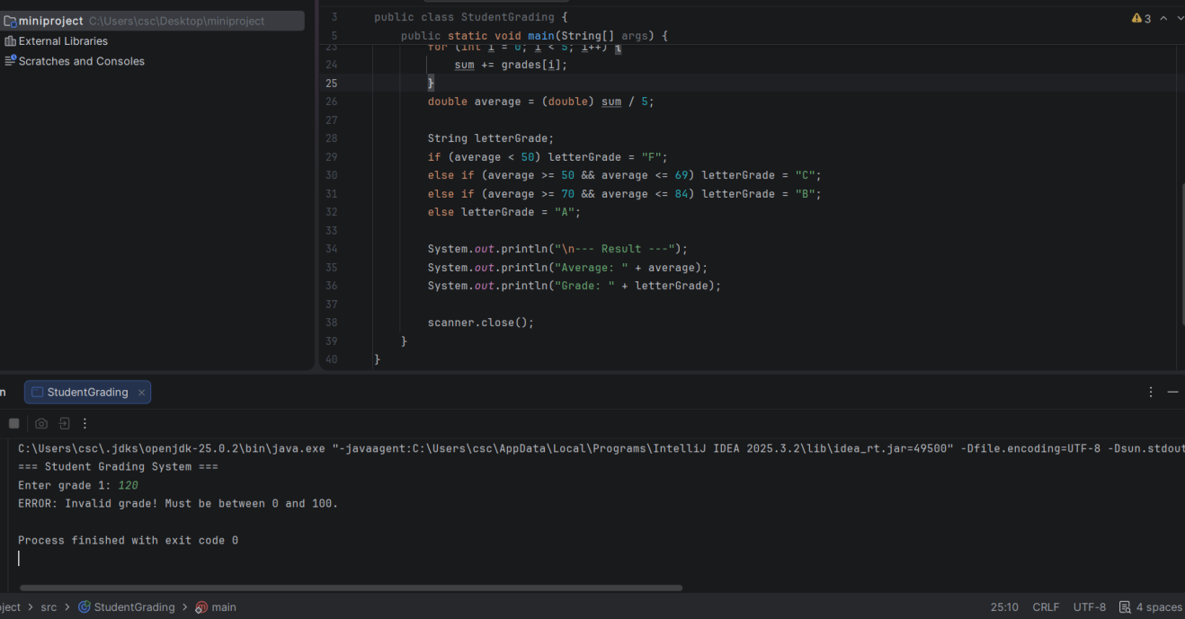

Regression Testing:
Title: verify that system shows error when entering grade -5 (one of grades)

Description: Verifying that program issues an error once entering an under zero value.

Steps: Open Studentgrading.java
Run the program
Enter “-5” as grade1
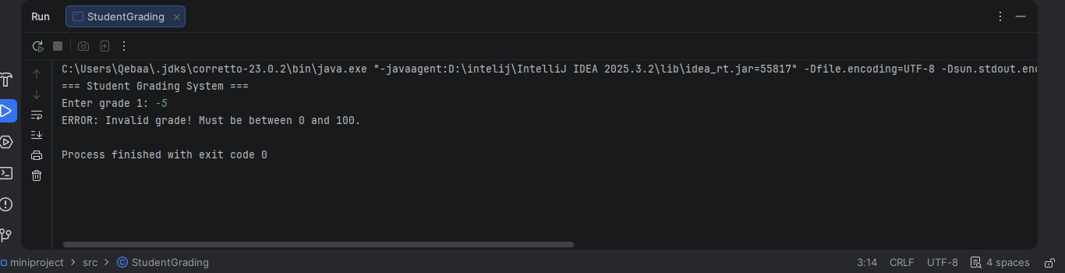
Result: Program issues an error confirming it’s an invalid value.

Title 2: verify that system shows error when no grades are entered .
Description: Verifying that system won’t accept an empty space as a value for grade and instead should show an error or wait for value entry

Steps: Open studentgrading.java
Run the program
Enter a space
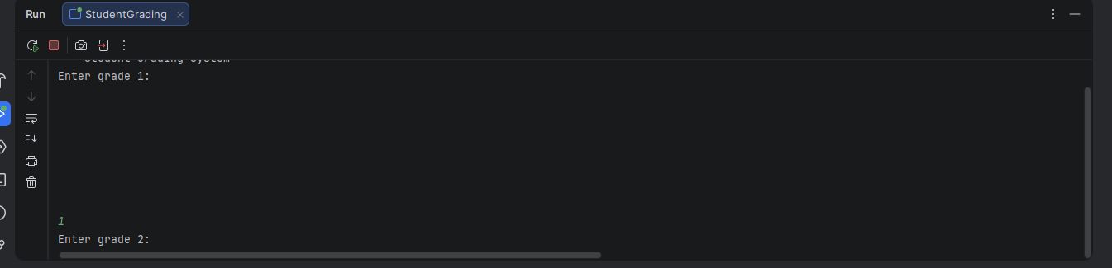
Result: Program doesn’t accept spaces and waits for entry of a valid value

Title 3: verify that system accepts grades
when average is 68.

Description: verifying that system accepts without error
(system assigns grade C , system calculates average as 68)

Steps: Steps: Open studentgrading.java
Run the program
enter grades in the array as follows : 70 , 70 , 68 ,66, 66.

Result: System accepts values correctly and assigns correct grade
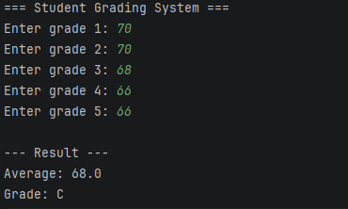

Title 4: verify that system accepts grades when enter 0 at all
Description: verifying that system accept without error
(system assigns grade F , system calculates average as 0)
Steps:
open the student grading.java
run the prorgam
enter grades in the array as follows : 0 , 0 , 0 ,0 , 0.
Result: System assigns grade F correctly and accepts values
